Pedigree of Anju Go Shirai
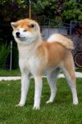  Anju Go Shirai  Red and White  Japan  2013 | 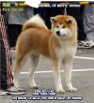  Fuuetsu Go Shirai  Red and White  Japan  2012 | 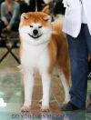  Kouki Go Shirai  Red and White  Japan  2011 | 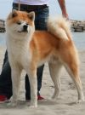  Ukyou Go Shirai  Red and White  Japan  2009
Mayu (Nayu) Go Shirai
Red and White
Japan
2010
 |  | Tamahime Go Shirai  Red and White  Japan  2008 | 119th AKIHO Headquarter Show 2008 - 1st prize; 79th Ibaragi-Ten - 1st prize; 82th Kanto Soshibu-Ten - 1st prize; 4th Kantochuou-Soshibu-Ten - 1st prize; 70th Tokyo-Ten - 1st prize  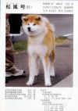  Matsukaze Go Musashi Aiwa  Red and White  Japan  2007
 |  | Tamahime Go Shirai  Red and White  Japan  2008 | Momoka Go Musashi Aiwa  Red and White  Japan  2006
 | Katsura Go Shirai  Red and White  Japan  2011 | WINNER Akita Cup 2013  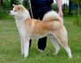  Ginji Go Shirai  Red and White  Japan  2010 | 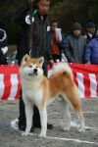  Awa Unjou Go Kisarazu Nomura  Red and White  Japan  2008
 | Katsura Go Shirai  Red and White  Japan  2011 |  | MEIYOSHO WINNER 2011  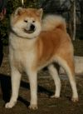  Sara Go Shirai  Red and White  Japan  2006
 | Katsura Go Shirai  Red and White  Japan  2011 | Shion Go Musashi Aiwa  Red and White  Japan  2008 | 119th AKIHO Headquarter Show 2008 - 1st prize; 79th Ibaragi-Ten - 1st prize; 82th Kanto Soshibu-Ten - 1st prize; 4th Kantochuou-Soshibu-Ten - 1st prize; 70th Tokyo-Ten - 1st prize  Matsukaze Go Musashi Aiwa  Red and White  Japan  2007
 | Katsura Go Shirai  Red and White  Japan  2011 | Shion Go Musashi Aiwa  Red and White  Japan  2008 | MEIYOSHO WINNER 2011  Sara Go Shirai  Red and White  Japan  2006
This pedigree was generated by Akita Inu Pedigree

